AWS

1. POLICY= is all about actions and permissions

Alarm = is all about conditions

1. EC2 instance types?
2. General purpose
3. Compute optimized
4. Memory Optimized
5. Storage optimized
6. Instance features
7. Measuring Instance performance
8. Accelerated computing
9. What is network ID?
10. What is Broadcast ID?
11. S3 bucket types?
12. S3 standard
13. S3 Intelligent-Tiering
14. S3 Standard-IA
15. S3 One Zone-IA
16. S3 Glacier
17. S3 Glacier Deep Archive
18. S3 Outposts
19. Performance chart

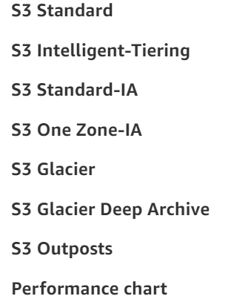

1. VPC components

**AWS VPC is made up of several networking components, some of them are as follows:**

1. Subnets.
2. Elastic network interfaces.
3. Route tables.
4. Internet gateways.
5. Elastic IP addresses.
6. VPC endpoints.
7. NAT.
8. VPC peering.
9. what is Nat-gateway
10. What is Cloud watch?
11. VPC end points?
12. What is the meaning of 2/2 check passed?

Check 1 - Instance status check

Check 2 - System status check

|  |  |
| --- | --- |
| Let’s say we have status check as 1/2 what does that mean? | Let’s say we have status check as 0/2 what does that mean? |
| It means instance status check is failed. | It means system status check is failed.  When system status (hard ware) is failed, obviously instance will fail |
| Solution: Reboot the instance  When we reboot, OS will be reloaded. | Solution: Stop and start the instance  Ec2 machine will be migrated to another physical machine |

1. What is Glacier?
2. Can you give me the one example of horizontal scaling?
3. Steps of ec2 launching or what is the procedure and steps to launching EC2 instance?
4. Choose AMI
5. Choose instance type
6. Configure instance
7. Add storage
8. Add tags
9. Configure security groups
10. Review
11. Difference b/w NACL & security groups
12. What is security groups? Why we use SG?
13. What are the ports?
14. Can u define port numbers of SSH, HTTP, HTTPS, RDP?
15. What are inline policies?
16. Auto scaling, life cycling of auto scaling?
17. vpc endpoints?
18. What is transit gateway?
19. What is instance profile?
20. Route 53, route 53 meta-value, route policies?
21. Use case of VPC flow logs?
22. Load balancer? Why the load balancer going to targets without doing health checks?
23. Let’s assume I stopped my instance and it shows like stopping, but it didn’t came to stopped position even for long time. By the end of year it gives me huge amount? What I have done mistake?
24. Let’s assume I created EC2 instance, If I’m trying to connect ec2 instance and I’m able to connect so what is the basic stuff here?
25. Load balancer creation steps?

A load balancer accepts incoming traffic from clients (end users) and routes requests to EC2 instances (Targets=ec2). It is responsible for 2 tasks:

* Load balancer will receive the traffic and distributes the traffic to registered targets.
* The load balancer also monitors the health of its registered targets (webserver) and ensures that it routes traffic only to healthy targets.

Go to load balancer service and select “classic load balancer” module and later

Step 1: Define load balancer

There we have to mention load balancer name and VPC name and have to select ports

Step 2: Assign Security Group

We have to select security groups (existing)

Step 3: Configure Security settings

Step 4: Configure Health Checks

Here we have to give the protocols server (Ex: HTTP) and port number of server (ex: HTTP=80) and have to be ping the path of web server (/index.html) and we have to mention advanced details like >>

Response timeout: 2 (Here load balancer send the ping request waits for response from browser)

Interval : 5 to check weather the server is health or unhealthy by giving time interval (How frequently load balancer should monitor the health. Once for every 5 sec here)

Healthy threshold: 2 ( )

Unhealthy Threshold: 2

Step 5: Add Ec2 Instance: Mention the number of ec2 instances here

Step 6: Add Tags (Mentioning the tag name)

Step 7: review

1. What is the Abbreviation of HTTP, SSH, HTTPS, HTTPD, RDP?
2. HTTP - Hypertext Transfer Protocol
3. SSH - Secure Shell
4. HTTPS-Hypertext Transfer Protocol Secure
5. HTTPD-Hypertext Transfer Protocol daemon
6. RDP=Remote Desktop Protocol

We have 0 to 65535 ports

Every port is dedicated to special purpose

RDP -- 3389

SSH -- 22

HTTP -- 80

HTTPS - 443

1. What is Webserver?

A Web server is a program that uses HTTP (Hypertext Transfer Protocol) to serve the files that from Web pages to users, in response to their request.

Ex:

1) Apache HTTP Server

2) Internet Information Services (IIS)

3) nginx

4) httpd by Apache

1. What is httpd?

HTTP Daemon is a software program that runs in the background as a web server.

It waits for the incoming server requests.

The daemon answers the request and serves the hypertext and multimedia documents over the Internet using HTTP.

1. What is Autoscalling?

Auto Scaling helps you to ensure that you have the correct number of EC2 instances available, to handle the load for your application. You create collections of EC2 instances, called Auto Scaling groups.

You can specify the minimum number of instances and the maximum number of instances in Auto Scaling group, and Amazon EC2 Auto Scaling ensures that your group never goes above this size.

1. What are the steps involved in the creation of Autoscalling?

Step 1: Create load balancer.

Step 2: Create Launch configuration

Step 3: Create Auto scaling group. -- Min, max

Step 4: Create Topic in SNS (Simple Notification Service)

Step 5: Create Alarm in Cloud Watch Service

Step 6: Add Policy in Auto Scaling

1. What is Yum Repository?

YUM Repositories are warehouses of Linux software.

Sometimes the software we want to install is not available in Linux OS default.

In such situations, we can use YUM Repositories.

We can install new software on Linux with

$yum install package_name command from console.

Installing Web Package

sudo su

Yum update -y

Yum install httpd -y

service httpd start

chkconfig httpd on (This command will help to start httpd service automatically, whenever machine is restarted)

cd /var/www/html

echo "MyGoogle" > index.html

1. what is elastic ip what is elastic ip
2. What is EC2?

Amazon Elastic Compute Cloud (Amazon EC2) provides scalable computing capacity in the Amazon Web Services (AWS) cloud.

Using Amazon EC2 eliminates your need to invest in hardware up front, so you can develop and deploy applications faster.

Synonyms:

Computer, machine, box, PC, Server = As per AWS terminology – Instance

1. What is the command to see cpu, memory and swap memory utilization?

$top  
$htop

$df -h

1. EC2 instance types
2. S3 bucket types
3. vpc components
4. what is Nat-gateway
5. what is Cloud watch
6. what is Glacier

DEVOPS:

1. Docker Commands
2. What is Jenkins Plugin?

Plugin is a UI developed which will translate into low level commands. These UI will help in doing the job easily.

1. Where is stored all the data of Jenkins builds?

Jenkins Backup and restore:🡪

All of the Jenkins data is stored in the Jenkins home directory= /var/lib/jenkins

Easiest way of taking backup is create a sync of Jenkins home directory in some other system

Sample Highly Available Jenkins setup

Periodic Backups of Jenkins using Plugins

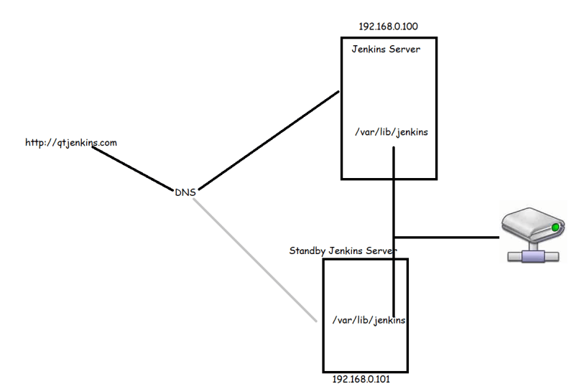

1. What is difference between thin backup and periodic backup?

Thin backup is mostly towards configure files and it doesn’t care about full backup. Compare with thin backup, periodic backup is better one it backups the config files as well as full backup.

1. what is is namespace
2. what is Kubectl in k8s
3. what is Kubeproxy in k8s

11. What is terraform modules and use of it?

12. scripted pipeline and declarative pipeline

13. How to operate Jenkins through command line

14. Push vs. pull

15. ansible modules

16. ansinble node default path

18. docker architecture

19. What is docker swarm?

21. Ansible Architecture

22. Diff b/w docker and containers?

23. Diff b/w git and svn?

24. What did observe in install and package of mvn?

25. Diff b/w merge& rebase

26. squash, stash

27. How to configure git hub to Jenkins?

28. Which plugins are used and installed in Jenkins?

29. What is artifactory?

Ans:

1. Roll based Authorized strategy

==========

What is artifactory?

**********

7.Docker Commands

8. what is Kubectl in k8s

9. what is Kubeproxy in k8s

10. what is is namespace

11. what is terraform modules and use of it

12. scripted pipeline and declarative pipeline

13. How to operate Jenkins through command line

14. Push vs pull

15. ansible modules

16. ansinble node defaulat path

18. docker architecture

19. What is docker swarm?

20.

21. Ansible Architecture

22. Diff b/w docker and containers?

23. Diff b/w git and svn?

24. What did observe in install and package of mvn?

25. Diff b/w merge& rebase

26. sqash, stash

27. How to configure git hub to jenkins?

28.. Which plugins are used and installed in Jenkins?

29What are the day to day activities a DevOps engineer will do and what are the challenges faced in previous project ?

30. What type of errors hàve you fixed if Jenkins pipeline failed means

==========

AWS

**********

1. steps of ec2 launching

2. Difference b/w NACL & security groups

3. What is security groups? Why we use SG?

4. What are the ports?

5. Can u define port numbers of SSH, HTTP, HTTPS, RDP?

6. Abbreviation of SSH, HTTP, HTTPS, RDP?

7. vpc end points

LINUX:

1. Different ways to debug the kernel code?
2. Do u know the different methods to deploy the module inside the kernel?
3. What are the different methods to find out the memory uses by linux?
4. Do u know how to edit a file without open a file linux?

Linux Shell:-

1. What is the command to check which shell we are using?

There are ways to find which shell we are using

1. echo$SHELL or 2.echo$0

1. What is the command to see How many shells were install in machine ?

cat /etc/shells

1. How can we change from one shell to another shell?

Need to mention command name like: csh or bash or ssh

If we want to left that shell simply exit

1. What is the command to see users default shell?

Grep username /etc/passwd

1. How can we change one user shell?

Usermod -s shellname username

Ex: usermod -s /bin/csh myuser